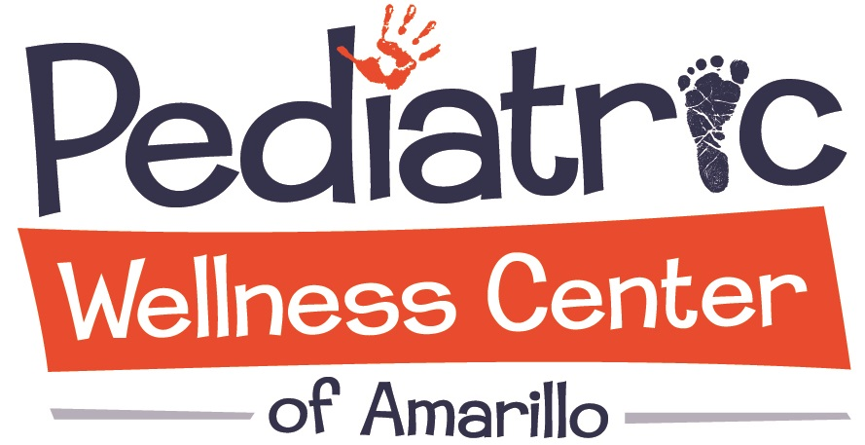 | 1901 Medi Park, Suite 110  Amarillo, TX 79106  Phone: (806) 468-4310  Fax: (806) 468-4311
REGISTRATION FORM
Date: ______________________

Patient: ___________________________________________________________________________________________
Last First Middle Nickname
Date of Birth: ________________ □Male □Female

Street Address: ________________________________ City: __________________ State:__________ Zip: ________

County of Residence: _______________________________ Child’s Social Security#: ___________________________

Home Phone#: _____________________ Cell Phone#: ______________________ Other: ________________________

Patient Living with_______________________________ Parent Responsible for Bill: ___________________________

Mother’s Name: _______________________________ Date of Birth:____________ Social Security#:_____________

Address (if different): ___________________________ City: __________________ State:__________ Zip: ________

Email address: ___________________________________________________

Employer: ______________________________ Department: _______________ Work Phone:____________________

Father’s Name:________________________________ Date of Birth:____________ Social Security#:_____________

Address (if different):___________________________ City: __________________ State:__________ Zip: ________

Email address: ___________________________________________________

Employer: ______________________________ Department: _______________ Work Phone:____________________

Person to contact in an emergency: ______________________________________________________________________
(MUST HAVE) (Not living at home of patient)

Address: ______________________________________ City: __________________ State:__________ Zip: ________

Home Phone#: _____________________ Cell Phone#: ______________________ Other: ________________________

INSURANCE INFORMTATION (Needed for PWCA referrals or diagnostic tests)

- Insurance Company: ______________________________ SS/Policy#:___________________ Group#:__________

Mailing Address: ___________________________ City:_________________ State:____________ Zip:_________

Name of Insured: ____________________________ Employer: _____________________ DOB:________________

- Insurance Company: ______________________________ SS/Policy#: __________________ Group#:___________

Mailing Address: ___________________________ City: _________________ State:____________ Zip:_________

Name of Insured: ____________________________ Employer:_____________________ DOB:________________

Medicaid#: _______________________________ Effective Date:___________________ Cert. Date:_______________

1901 Medi Park, Suite 110
Amarillo, TX 79106
Phone: (806) 468-4310
Fax: (806) 468-4311
Date: ______________________

Patient Name: ___________________________________________ DOB:_____________________

CONSENT TO TREATMENT: The undersigned consents to receive medical and healthcare services provided by physicians, advance practicing nurses, nurse clinicians, and other healthcare providers of the Pediatric Wellness Center of Amarillo (PWCA) practice. Such services may include diagnostic procedures, examinations, treatments, or other services rendered under the general and special instruction of the providers. Specific services may require informed consent. E.g., declining vaccinations.

This signed consent to treatment will be valid and remain in effect unless revoked by the undersigned with a written notice provided to PWCA.

RELEASE OF INFORMATION: PWCA may disclose all or any part of my medical record including oral information and provide my bill/invoices to: (1) any person, corporation, or agency (or their authorized representative) which is or may be liable under a contract to PWCA, or to me or my family members for all or part of the clinic charges including, but not limited to, hospital or medical service companies, insurance or third party payers, workers’ compensation carriers, or my employer; and (2) any individual or entity designated by me as a guarantor or party responsible for payment of fees for healthcare services provided to me.

The undersigned understands and agrees that the information authorized to be released may include (1) AIDS/HIV test results, diagnosis, treatment and related information; (2) information about drug and alcohol use and treatment; and (3) mental health information.

The undersigned understands that this authorization for the release of information may be revoked at any time, by providing written notice to PWCA, except to the extent that action has been taken in reliance on it. Unless earlier revoked, this authorization expires automatically ninety (90) days from the signed date or ninety (90) days after the last clinic visit or after all insurance or third party claims have been paid or satisfactorily resolved, whichever occurs last.

RELEASE FROM LIABILITY: The undersigned releases and agrees to hold harmless PWCA employees from any and all liability associated with the release of confidential patient information in accordance with the authorization and understands that PWCA cannot be responsible for use or re-disclosure of information by third parties.

FINANCIAL RESPONSIBILITY AND ASSIGNMENT OF BENEFITS: In consideration for receiving medical or healthcare services, the undersigned hereby assumes responsibility for payments for such serves at the time services are rendered. Payments may be made in cash, checks, or with a credit card. The responsible party may choose to submit charges assessed for rendered services to his/her insurance company or other payers. The undersigned acknowledges that PWCA will not submit any bills to either the guarantor or any insurance company for services rendered at any time.

The undersigned certifies that this form has been fully examined and any questions have been answered by PWCA and its content is understood and agreed to.

 | Date Time
Parent/Other Legally Authorized Person | PWCA Witness and / or Translator
Print Name and Relationship to Patient | Print Name and Translated Language

